Functional Specification


Elunch

Release : v1.2
Date : 24 Jun 2015
Authors: NGUYEN P.X. Thien

Report History

Document Location
This document is only valid on the day it was printed.
The source of the document will be found at XX

Revision History
Revision date | Author | Version | Summary of Changes | Changes marked
24-Jun-2015 | Theodore NGUYEN | V1.2 | Update user backlogs

Approvals
This document requires the following approvals:
Name | Title | Date of Issue | Version

Distribution
This document has additionally been distributed to:
Name | Title | Date of Issue | Status
Table of Contents Page

1 Report History 2
Document Location 2
Revision History 2
Approvals 2
Distribution 2
2 Purpose 4
3 Background 4
4 Metrics 4
5 Scope 4
In Scope 4
Out of Scope 4
6 Timescales and Priorities 5
7 Summary of Business Requirements 5
8 Policy and Issues 5
9 Summary of Functional Areas 5
10 Functional Requirements by Module 6
Module 1 : PROG 6
11 Screens and Workflows 7
12 User Interface Description 9
13 Interfaces to other systems 9
14 Reporting 9
15 Users and Security 10
16 System administration and maintenance 10
17 Non-Functional Requirements 10
18 Appendices 10

Purpose
The purpose of this document is to summarise the functional requirements of ELunch. It is not a system solution, but a guideline of the required system functionality.
The document sets out detail of
- Metrics
- User types
- The modules
- User tasks
- Functional requirements of each module.

Background
Enclave has been worked with many lunch suppliers since its early days, from having lunch in separated lunch box to having lunch as in a lunch table. There are always problems with the quality of the lunch and lunch tracking. The quality was sustainably downgrade as time goes by, the lunch tracking is difficult with the manual tracking way, many meals were wasted in vain when employees didn't have lunch without notice. Trying to overcome these problems, E-Lunch project provides a solution that helps
- The administrators manage the indoor lunch easier, tracking seats, meals, serving based on the table's demand.
- The engineers feel more comfortable with the lunch service. Now, with a smart phone, they can know what dishes they have today; they can comment to the service for the quality or any facts related; they can give their suggestion for the lunch menu by votes; they also can put a message to the service that they don't use lunch or be notified to have lunch when their table is ready.

Metrics
The system is required to cater for the following approximate current volumes, (based on figures from YEAR)

Scope

In Scope
- Manage lunch menu of a company: The service staff uses the system to create lunch menu for a week. He later can make some changes on the menu like replace the dishes.
- Menu suggestion (by votes): The service gives a list of dishes, then the engineers come and choose their favourite dishes by votes. Each engineer will have 5 votes a week.
- Arrange employee's seats, manage seats: The administrators manage the seats of table. The engineers can choose their seat.
- Make comments to the lunch service: The engineers make comments about the dishes they have, suggest the idea to make the service better. The administrators can reply to these comments then.
- Message/ Email to the engineers to remind have lunch on time
- The administrators can tracking the number of lunch meals per day, month or specified range.

Out of Scope
N/A

Timescales and Priorities
When are different functional areas of the software required by and what are the business/operational reasons?

Summary of Business Requirements
Summary of business requirements that have been selected for this phase of development following review of the Statement of Requirements, with:
- brief descriptions
- priority
- cross reference to the Statement of Requirements
Optionally could include details of requirements identified in the Statement of Requirements that have not been selected (for this phase of work) and reasons why. However this might be placed in the Appendices (see final section below).

Policy and Issues
Particular points to consider that may influence the development. Decisions regarding why it should be done in one way and not in another way.

Summary of Functional Areas
Brief summary of key functions required – if possible with diagram illustrating the relationship between them.

Functional Requirements by Module
This section sets out the functional requirements of the system by module. It would include details of key functions that the system must perform:
- Key processes (including bulk processes, workflows etc)
- Creation/Amendment/Deletion of records
The requirements set out here are ranked in MoSCoW order:
M – Must Have
S – Should Have
C – Could Have
W – Would like to have

Module 1 : E-Lunch Front end
The end-users view, vote, and comment on the menu. They select to join in a table or leave a table.
Roles: engineer (customer)
Function Id | 1. Front end Functional description | Priority Level  (MoSCoW) | Key Analysis Points/Notes | Business Requirement (in SoR)
1.1 | As a customer, I want to update my profile (for ex. Want vegan meal, have allergy with...) | M
1.2 | As a customer, I want to book a seat in a table so that it's the permanent table of my lunch onward. | M
1.3 | As a customer, I want to book a seat in a vegan table for 1st and 15th Lunar month when I set 'want to have vegan meal' in my profile | M
1.4 | As a customer, I want to leave a table so that I can join in another table | M
1.5 | As a customer, I want to see the menu for a week. | M
1.6 | As a customer, I want to vote for my favourite dishes so that the lunch staff can use the statistic to make a good menu. | M
1.7 | As a customer, I want to comment on the dish/ meal | M
1.8 | As a customer, I want to check whether my table's ready or not so that I can come get my lunch | M
1.9 | As a customer, I want to note the lunch staff/ other members in table that I won't have lunch on specified date. | M
1.10 | As a customer, I want to view the response of my comments from the lunch staff | M
1.11 | As a customer, I want to be notified to have lunch on time

Module 1 : E-Lunch Back end (Dashboard)
The administrator can manage users, shifts, tables (A shift has 1 or many tables); can update the seat's status at a specified lunch time.
The lunch staff can manage the dishes, menus; can remind the customers when table's ready or when they come late.
The manager can view report about pre-ordered meals, actual meals of a day (by range); can visually view the status of the seats of tables (seat's status: absent, having lunch, not coming)
Roles: Administrator, Lunch Staff, Manager
Function Id | 2. Back end Functional description | Priority Level  (MoSCoW) | Key Analysis Points/Notes | Business Requirement (in SoR)
2.1 | As an administrator, I want to manage user accounts | M
2.2 | As an administrator, I want to organize seats of tables (includes switch 2 seats of 2 different tables, add more seats/ remove seats from a table) | M
2.3 | As an administrator, I want to set status of every seats of tables at lunch time so that the manager can see how many actual meals for that day, and can be used for reporting purpose later. | M
2.4 | As a lunch staff, I want to manage dishes (by categories) | M
2.5 | As a lunch staff, I want to have small gallery for each dish so that the front end can visualise the dish to the customers | M
2.6 | As a lunch staff, I want to manage menus (including create menu, add dish, remove dish) | M
2.7 | As a lunch staff, I want to notify a table members when table's ready, or remind a member to have lunch on time | M
2.8 | As a lunch staff, I want to add extra meals when all pre-ordered meals are consumed. | M
2.9 | As a manager, I want to view report about actual meals, extra meals of a day | M
2.10 | As a manager, I want to view seats' status of every tables so that I can see whom don't have lunch that day | M

Screens and Workflows
For an internal development the Functional Specification should contain details of the screens required with:
- Basic mock ups
- Links to processes defined in the Functional Areas
- Details of the workflow between the screens, i.e. data flow, inputs and outputs

In the case of amendments/enhancements to existing systems (either internally or externally provided) the Functional Specification might include suggestions for changes to existing screens which are already in operation in order to meet business requirements.

Main page: Displays the menu for today and for tomorrow. It's the first page shows up after user logs in.
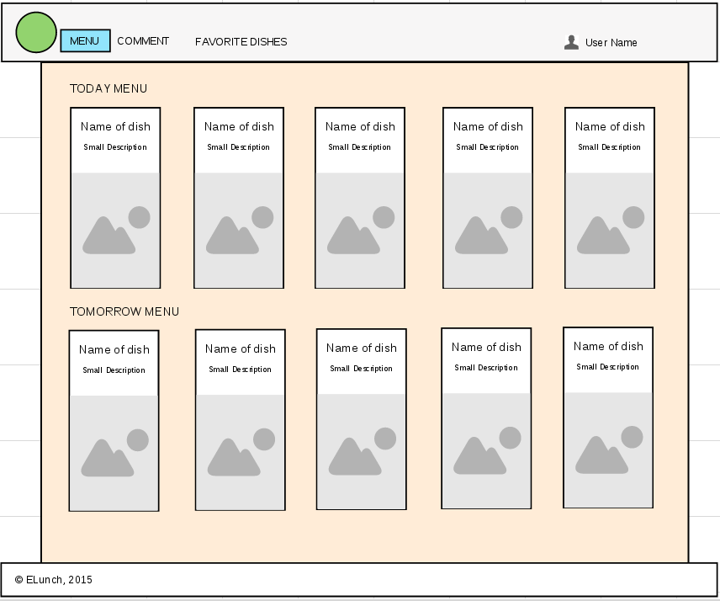

Leave a comments: The engineer gives feedback to the service

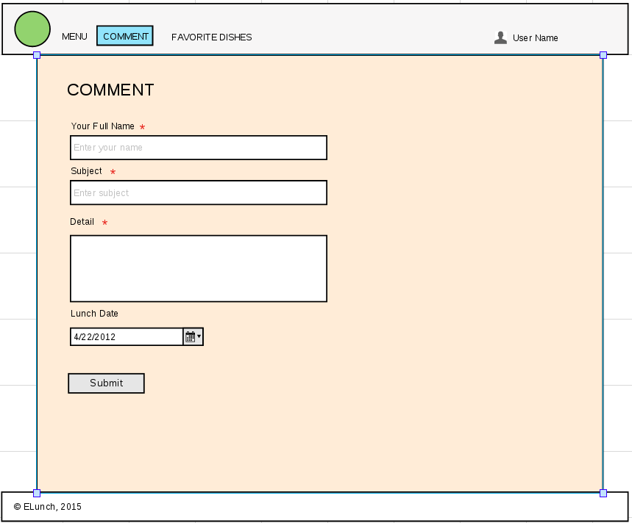
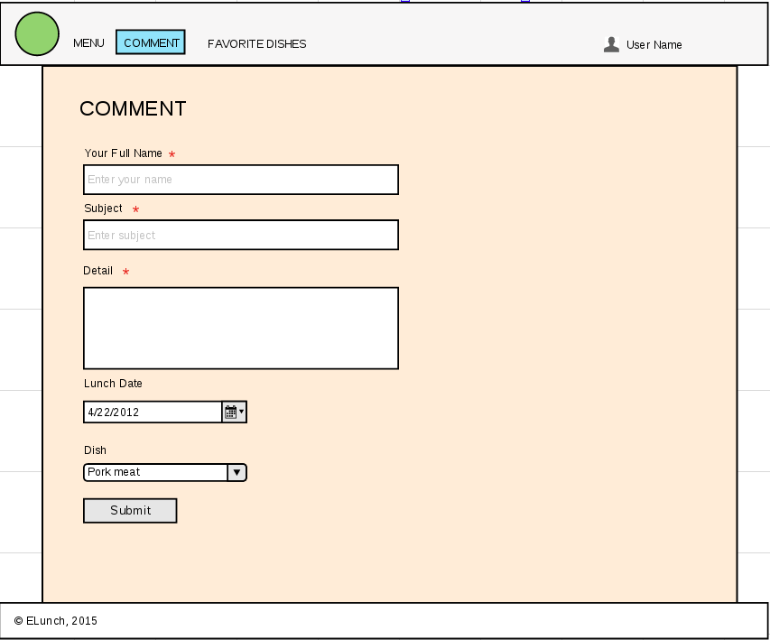
Click on Submit button, it redirects to another page with the text: “Thank you for your time to feedback us. We will reply you soon.”

Favourite Dishes: The engineers can vote for their favourite dishes. These votes help the service knows its customers' demand, and build the menu.
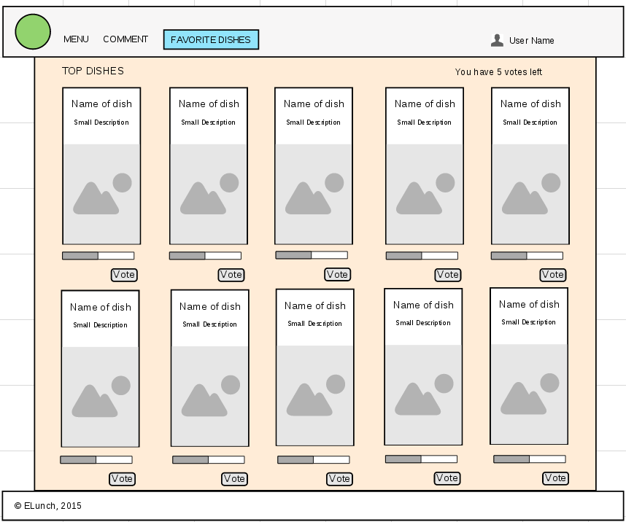

Select Table: User selects a table, click Join to join in that table

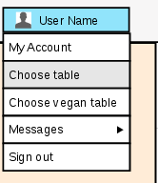

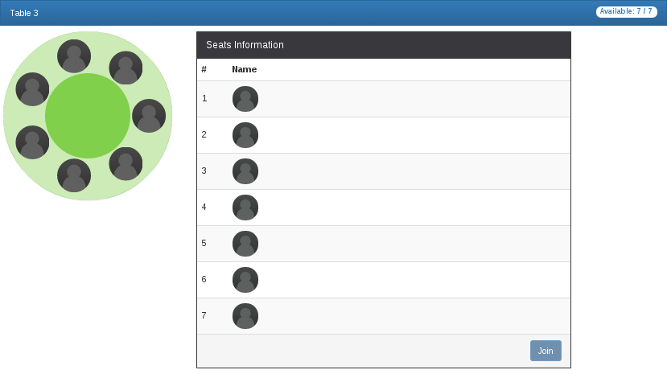

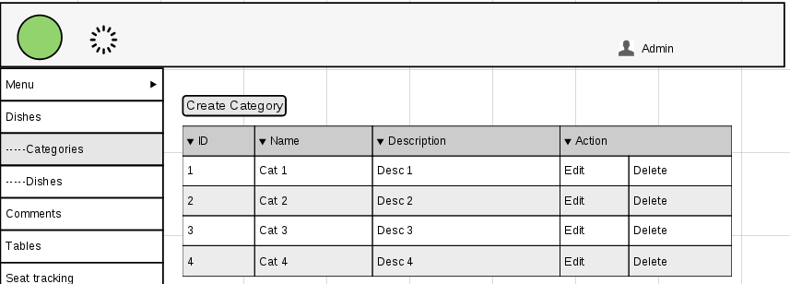
Admin can create/update the dish category

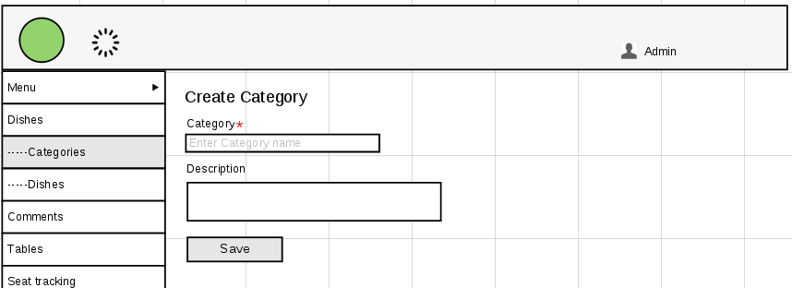
He clicks on Create Category button to create a new category

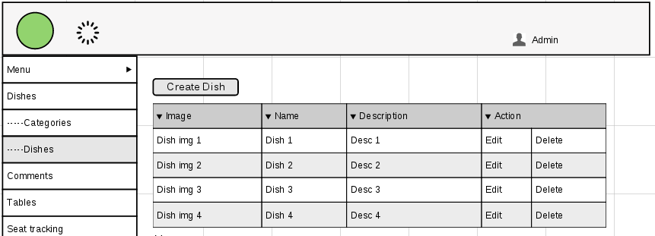
Admin can create/update the dish

He clicks on Create Dish button
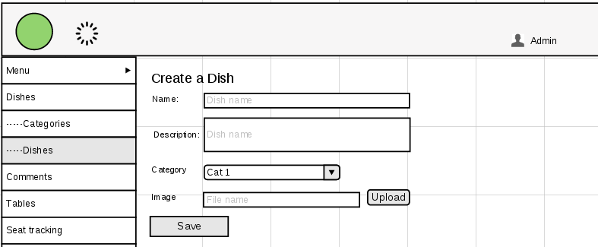
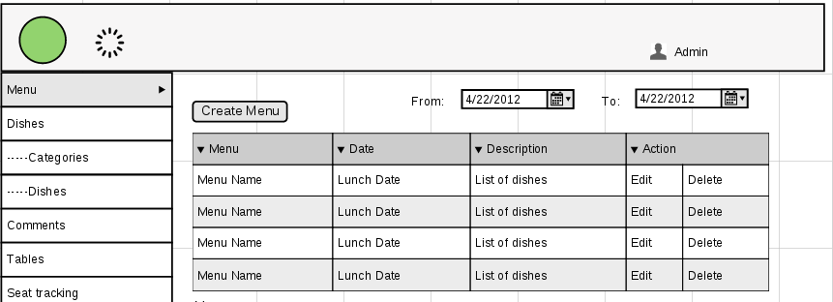
Admin can create/ edit a new menu:

He clicks on Create Menu button
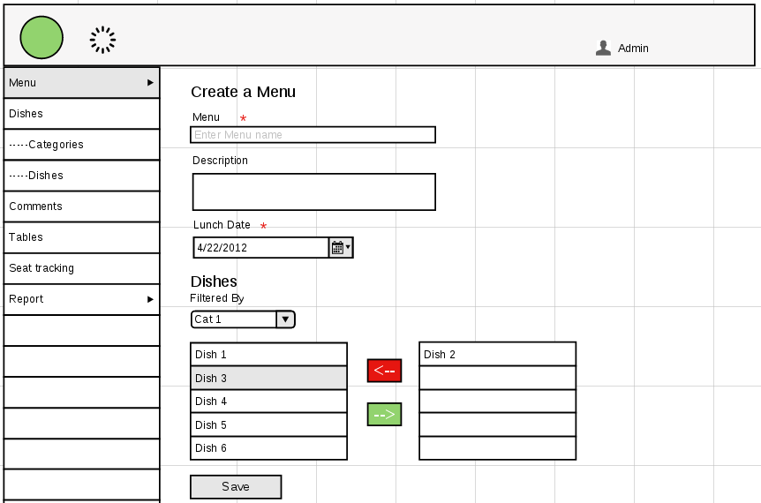

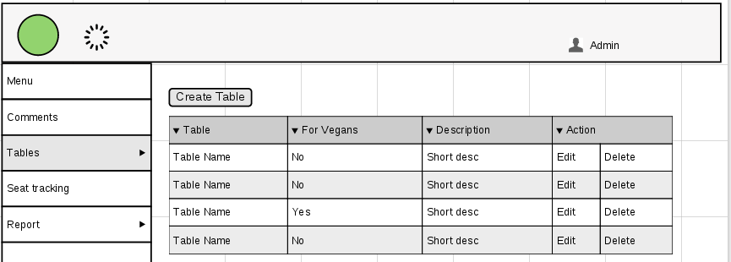
Admin can create new table

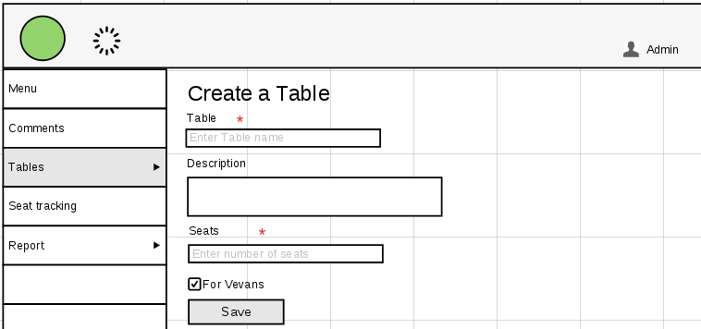
He clicks on Click Table button

Admin or staff can check the seat status:
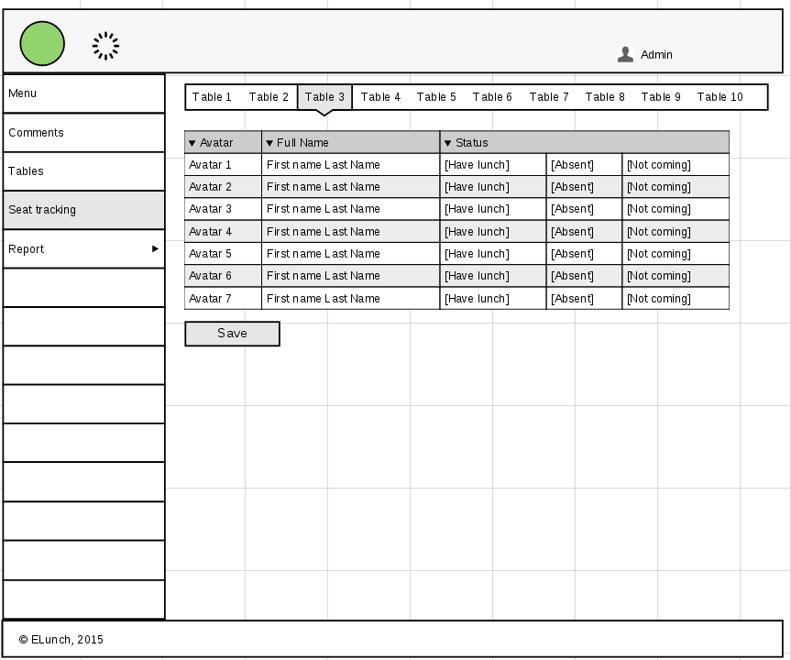

Admin views the comments: View all the comments from the engineers and select a comment to reply
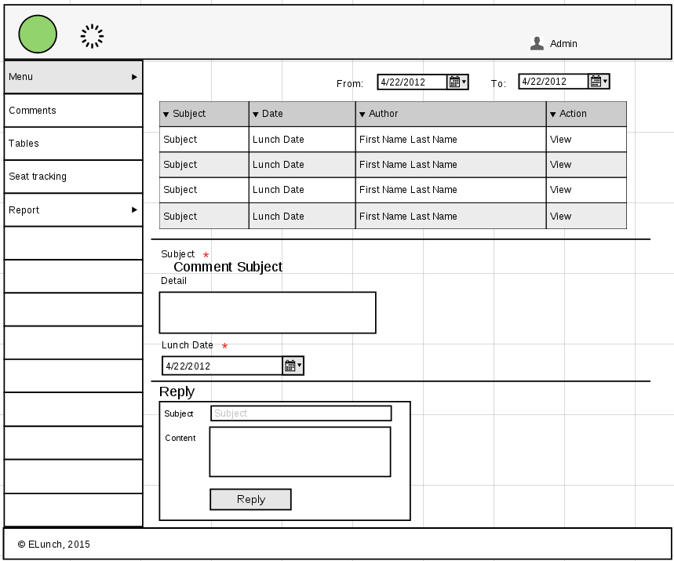

User Interface Description
Whilst the Business Analyst will not be designing the User Interface for a new system, the Functional Specification should include a description of the expected User Interface.

Interfaces to other systems
Interfaces required to other systems should be detailed, with information about the nature of the interface and of each system concerned.

Reporting
Details of any reports required including:
- Selection criteria
- Sorting and sub-totalling criteria
- Values to be shown in output columns
The intended recipients of each report should be recorded.

Users and Security

Different types of users/user roles
User permissions – i.e. where permissions are required to access:
- Specific processes
- Specific data

System administration and maintenance
How will base data in the system (e.g. users, parameters) be maintained and by whom? Who is the owner of the data?

Non-Functional Requirements
Where identified, relevant Non-Functional Requirements (requirements that do not specify what the software functions should do, but how the software should operate) should be specified. Ideally there should be some descriptive detail that will allow assessment of whether the requirement has been met (e.g. response time in the case of performance).
A checklist of non-functional requirements can be found.
Non-Functional Requirements should have already have been included in the SoR but these should be reviewed and amended if necessary for this document.

Appendices
These might include:
- Data catalogue where applicable - Where appropriate details of new data fields that need to be created and how they might be grouped into or added to a table and why
- Details of requirements identified in the SoR but excluded from this phase, with reasons why

